## Design Concept

After completing the prototype, we considered how to ensure smooth transitions between pages from the user's perspective. The interaction plan played a significant role in shaping our user flow. The user flow outlines the entire process from the moment users enter the interface to their interactions with various pages to obtain the necessary information. While the flow is not particularly complex, it thoroughly covers all the steps and information users can access. This section does not go into detail about the components and transitions on each page, but these will be explained in detail in the following sections.

This section also highlights a crucial aspect: usability research and user surveys. In this project, one issue was that the website’s purpose and target users were not carefully considered. For example, our initial design aimed to warn users of potential dangers while providing safety tips to avoid them. However, the project supervisors pointed out that this direction did not align with a suitable target audience. The inability to identify primary users meant we could not provide services tailored to their needs. This feedback guided the team toward a more appropriate objective. As a result, we shifted our focus to investors, establishing the website's purpose as assessing the safety levels of different areas.

Of course, this was just one major issue at this stage, while other issues were addressed through feedback at various phases to improve the website. Nevertheless, usability research and user surveys must not be overlooked at any stage.

## Phototype

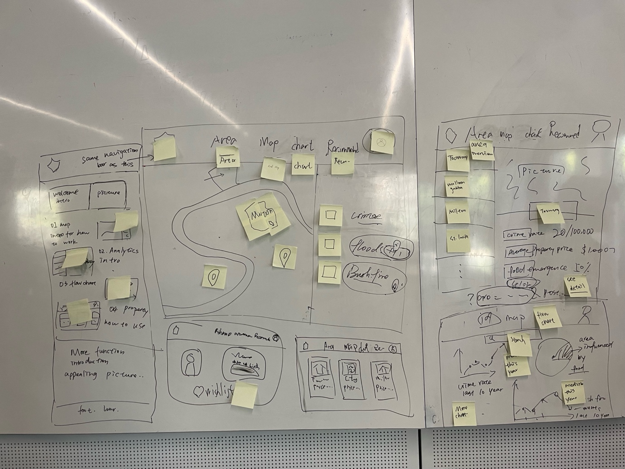

*Figure 1 Interaction Design Originals*

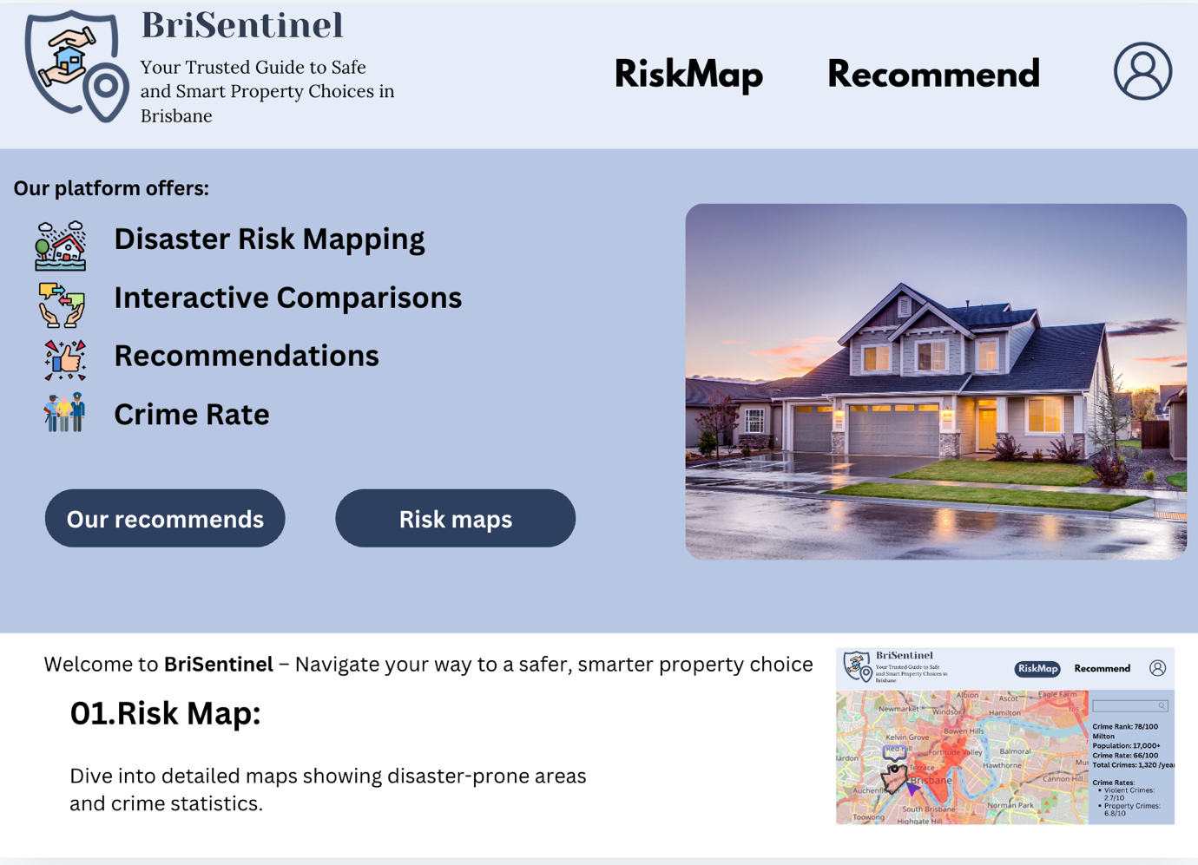

*Figure 2 Phototype of Help Page*

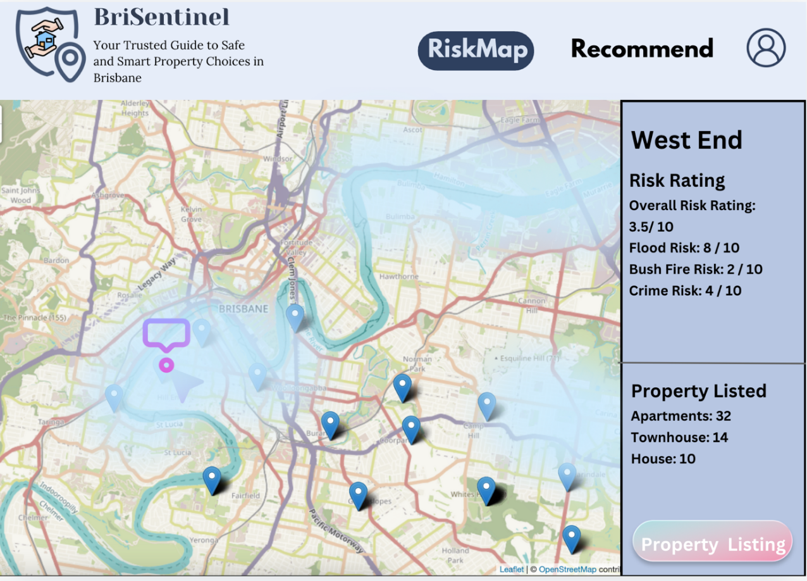

*Figure 3 Phototype of Riskmap Page*

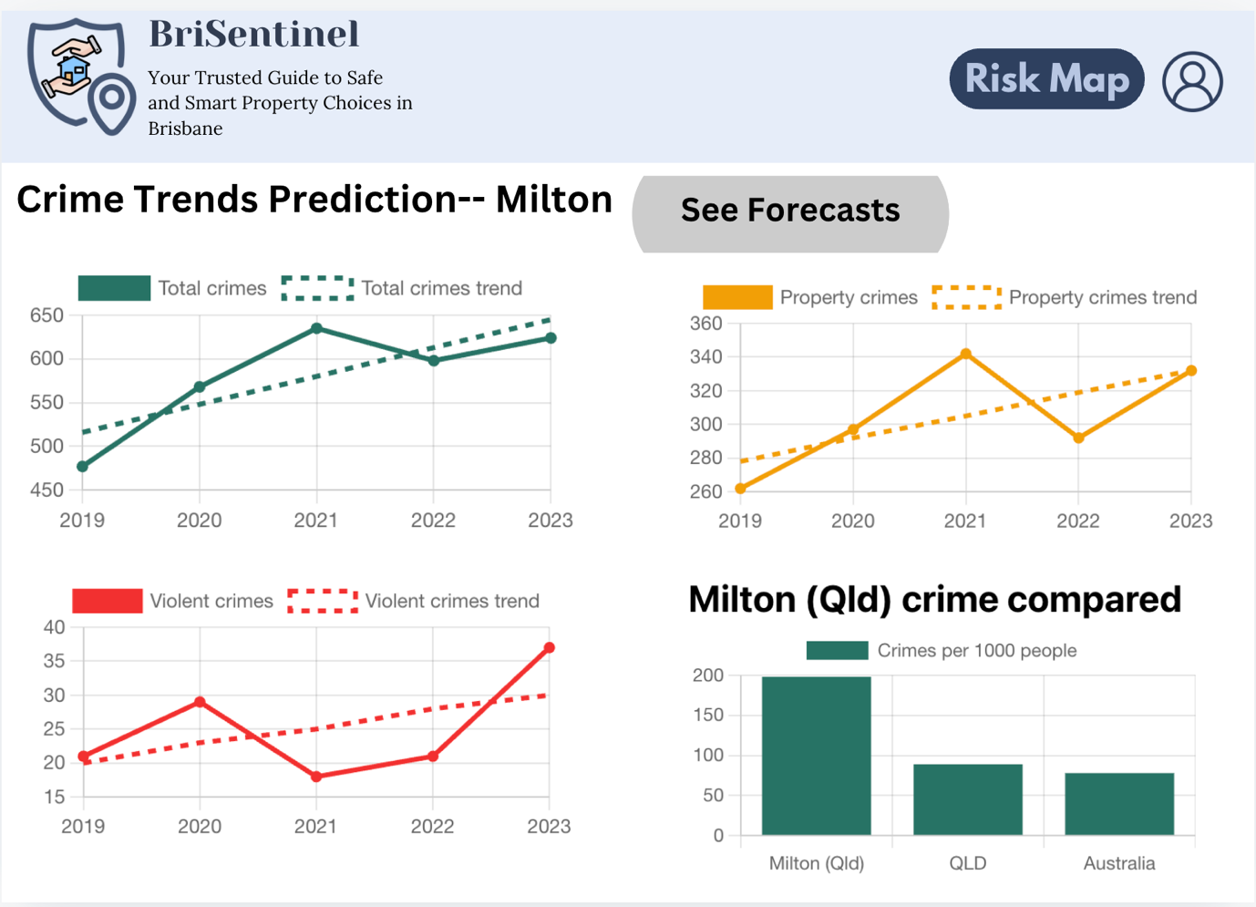

*Figure 4 Phototype of Chart Page*

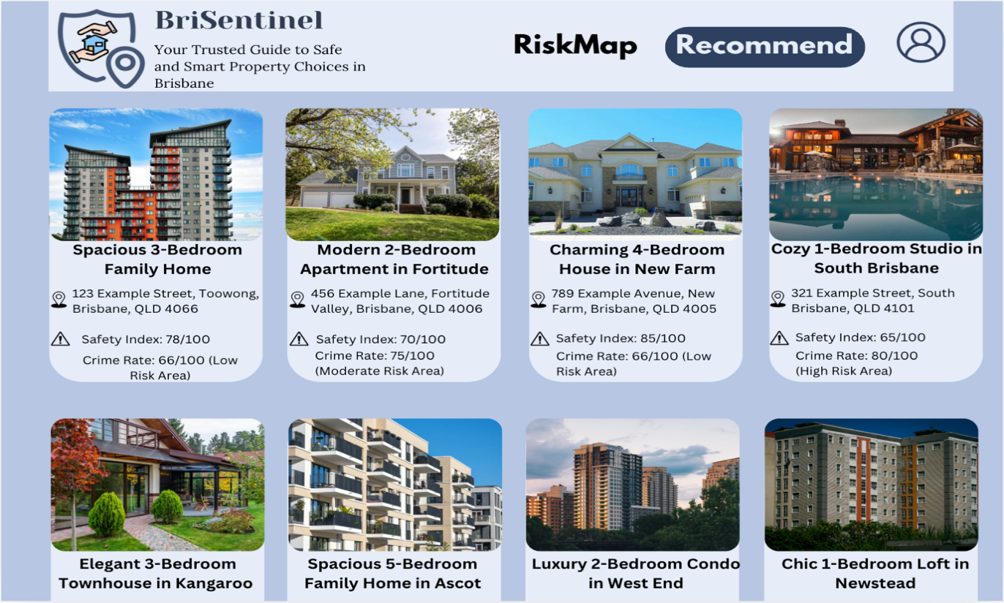

*Figure 5 Phototype of Property Page*

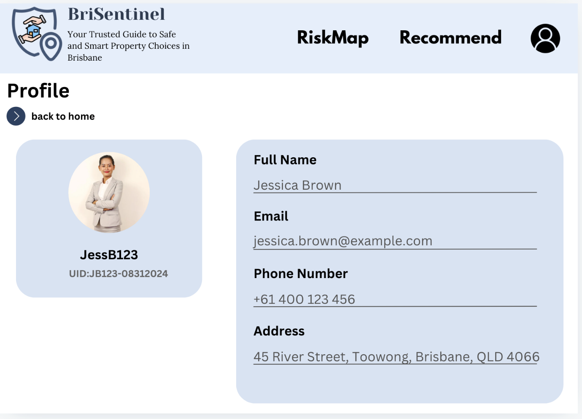

*Figure 6 Phototype of Profile Page*

After the designers completed the relevant web prototypes, the front-end developers wrote the corresponding code based on the designs to enable testing. We also considered the use of paper testing, which offers two key advantages. First, it allows us to clearly present all system components to users, even if some parts of our code have not yet been implemented. Second, it enables us to promptly correct any major directional errors before the formal development begins.

However, despite these advantages, there are also several disadvantages of using paper testing that need to be considered. For instance, we would need to spend a significant amount of time creating the paper prototypes. If any errors or changes occur, the prototypes must be entirely redone, which is not feasible given the tight project timeline. Additionally, during formal testing, the limited number of paper prototypes means that fewer users can be tested at the same time compared to digital web versions, resulting in less feedback. Moreover, the most important issue is that our pages contain too many elements. This can lead to the challenge of managing a large amount of paper during the testing process, making it difficult to accurately measure interaction times

Based on the considerations above, we decided to proceed directly with user testing after completing the main functionality in the code. This way, even if errors occur, we can make modifications immediately, significantly saving time and improving efficiency. The primary objectives of this user testing were as follows: to evaluate whether the website runs smoothly, to assess whether it is aesthetically appealing, to ensure that the database content is properly displayed on the site and to determine whether users can effectively interact with the data.

### Sitemap

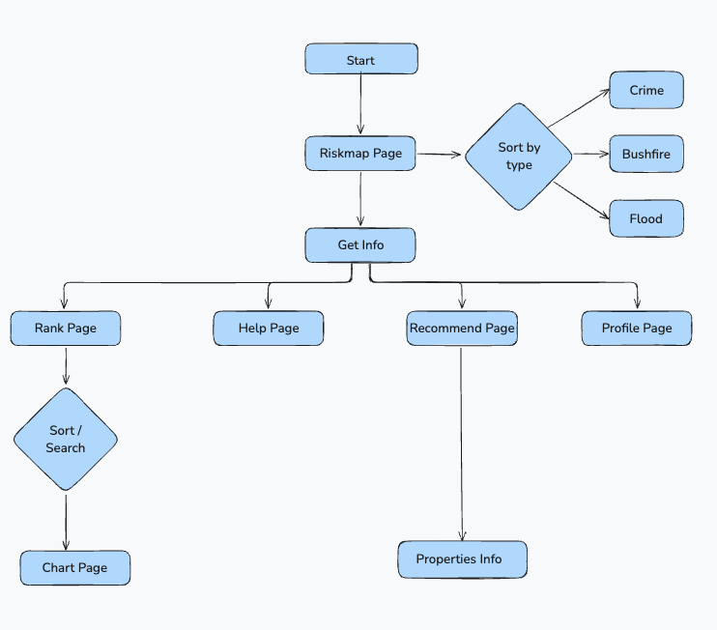

*Figure 1 Sitemap*

Our sitemap displays a directory of all the pages on the website. After entering from the homepage (Riskmap Page), you can access the information you need on the other four pages（Rank page, Help page, Recommend page and Profile page）

### Interaction Flow



*Figure 1 Interaction Flow*

The interaction flow provides an overview of how a user can interact with various pages within the website. It includes both the implemented and not yet implemented parts, as shown in the diagram.

## MVP

In this section (MVP), we will transform most of the design concepts mentioned above into a functional product and present it to the audience. After the demonstration, we collected user feedback to further improve our website. The core features implemented in this part include:

- Users can browse different suburb risk cases in Brisbane through the Risk Map.

- When users are interested in a specific suburb, they can view detailed information about the area on the Rank page.

- If users need more insights, they can access the Chart page of that suburb to see safety scores and data visualizations.

- Additionally, on the Recommend page, we provide property recommendations for users to explore.

**Feedback:**

* + In order to prevent users form waiting for a long time, we chose to add a load data button to the navigation bar, but the effect is not good. Due to the large amount of data and the limitations on request frequency, we decided to use cache files to store the data. This allows the website to respond quickly to user requests, thereby improving the overall user experience.

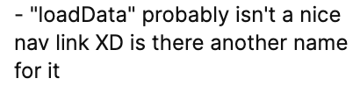

*Figure 1 Some feedback from MVP*

* + Users might not fully understand the purpose of our website when they first land on the Risk Map homepage. It is hard to find the” Help” button.
  + When users come across a property of interest on the Properties Page, there is no way to save it for future review.

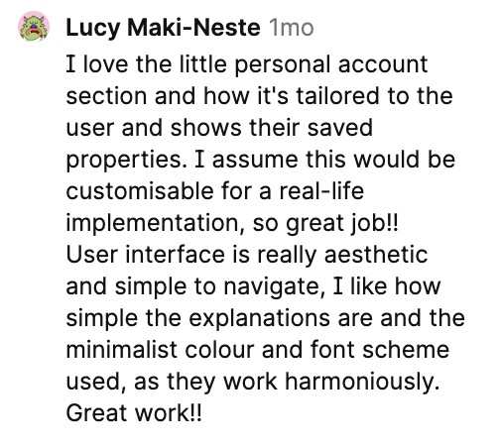

*Figure 2 Some feedback from MVP*

* + For those unfamiliar with the Brisbane area, they may not know which suburbs are available. Therefore, we need to add an extra search bar on the rank page and allow each suburb on this page to link to the corresponding location on the risk map with a highlighted view.
  + The style of Rank Page is different from other page styles

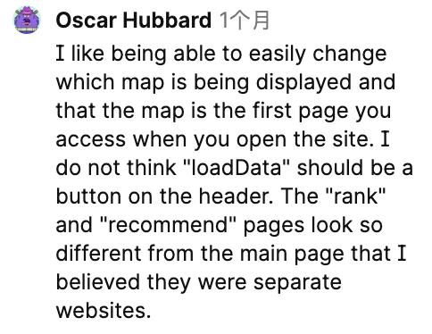

*Figure 3 Some feedback from MVP*

In this version of the development, we implemented the display of risk cases for various suburbs in Brisbane based on data from the database. When users hover over a specific area, the edges of that suburb are highlighted, and relevant information will be displayed. On the Chart page, we utilized the Google API to implement interactive charts. However, some parts of this version did not meet our ideal expectations. This was mainly due to communication issues within the team and time management challenges among members. Below, we will display some of our work in detail through a series of images.

The above summarizes what we have achieved and what is still in progress in this phase of the project. We hope that, through these improvements, we will be able to deliver a higher-quality product.

## **Future Plan**

### For Project

Although the web project did not achieve the team’s initial vision, we managed to complete most of the planned requirements. Overall, the project can be considered successful. However, due to insufficient time, some features initially intended for the website were not completed. Below, I will reflect on these unfinished features to prepare for further development in the future.

#### Forehand:

**Simplifying User Interactions:**

Although we integrated the SLQ dataset with the Google Maps API, we found that many users encountered complicated steps during their interactions, which reduced the usability of the website. To address this, we plan to simplify form filling and provide more detailed information options, ensuring users can efficiently find the information they need.

**Improving Aesthetics and Design:**

Currently, the website’s design is still quite basic. In future development, we will further optimize the layout and styling to better meet users' aesthetic preferences.

**Cross-Device Accessibility:**

To ensure users can access the website at any time, we aim to make the website accessible and functional on various mobile devices (such as phone and tablets). We also plan to implement responsive design to maintain layout consistency across different screen sizes, ensuring all features function properly.

#### Backhand:

**Expanding Dataset Coverage:**

Since the current dataset is limited to the Queensland region, a significant improvement would be to obtain data covering all of Australia. This would attract users from different regions across the country and encourage property investments in various areas.

**Data Handling:**

We used JSON cache files to store relevant data and achieve fast response times for the website. However, this method has a significant drawback – the data is not updated in real-time. Additionally, some data requires manual retrieval and insertion, which greatly increases time costs. To address this, a database should be established to directly fetch the required data. This would reduce maintenance costs and enhance real-time rendering speed, thereby improving the user experience.

### For Team

At the start of the design phase, there was some confusion. The division of tasks may not have been sufficiently detailed. The main issues stemmed from communication problems. Due to insufficient communication, the project lacked transparency. This may led to rework in some cases. In response, we have reflected on the following points:

- During the design phase, it is essential to define the technical stack and evaluate whether the chosen technologies are suitable for the project. This will shorten the development cycle and ensure that all members follow the same technical framework, avoiding inconsistencies in development styles.

- Allocating more time for communication will ensure that all members are aware of the project’s progress. This will also improve development efficiency and help avoid issues like rework.

- Team members should increase their estimation of the time cost required for the project. On one hand, it ensures that the project has enough time to be completed, and on the other hand, it allows for sufficient self-learning time to overcome challenging tasks, ensuring smooth project development.

- There was a time when we submitted a document late because everyone in the team assumed someone else had already submitted it. There was no communication between us, and we only realized after the deadline that it hadn’t been submitted. Although we eventually submitted it late, this incident revealed an issue: our team lacked a role responsible for managing task progress, which led to the problem above.

- During the mid-term product demonstration, each team was allocated only five minutes. Although we prepared a five-minute script, we still ran over time. We calculated the time required from start to finish but didn’t account for the combined time needed for the entire team. As a result, we exceeded the time limit and didn't fully present all the processes, which led to a lower score. This shows that there was a lack of communication within our team. More seriously, we lacked team spirit. Focusing too much on individual performance is something we need to correct in the future.

- In the final team task report, we encountered many issues. We divided the overall task into many smaller parts, and each person took responsibility for a portion. However, by the originally agreed deadline, some members had not completed their parts, which significantly impacted the overall time management. Upon gathering everyone's work, we found that the completion levels were not encouraging, and the quality was inconsistent. Moreover, there was no uniformity in writing format and style among team members. The priority was to fill in the incomplete sections. Formatting was relatively easier to address. However, the biggest challenge was that we did not have enough time to complete everything. Initially, we estimated that each person would take about five days to finish their part, with two days allocated for integration and finalization. However, we realized that within those final two days, not only did we need to complete the formatting, but also had to finish the incomplete sections. This was a significant challenge for the entire team. Fortunately, everyone contributed their valuable time in the end, allowing us to complete the revisions on time. Therefore, time management and a serious attitude toward tasks are essential for the successful completion of a project. These qualities are crucial for every member of the team.

### Conclusion

At the beginning, we introduced the general overview of the project and the objectives we needed to achieve. We then presented the team members and their contributions. When starting the project, we clearly defined all the project requirements. With the database we found, we designed the current website, while also drawing inspiration from existing applications in the market to avoid their shortcomings.

After summarizing these points, we began designing the website. We also considered our target users so that we could make the aesthetics design. As mentioned in this report, we continuously refined and revised our website, evolving from a rough initial product to a more polished version, consistently improving the user experience.

We then proceeded to the MVP demonstration, where we reported on both the implemented and simulated features. We received a lot of user feedback during this phase and further refined our website based on it. After this, we focused on demonstrating the functionality of our website, ensuring it met the requirements for three interactive pages and dataset interactions.

Finally, we conducted a detailed review of the entire project to evaluate whether we successfully met all the objectives. We also reflected on the shortcomings during the project and how we could make improvements in the future.

Although we encountered many challenges throughout the project, these experiences were valuable lessons. Every team member has gained insights and improved their skills, making them better prepared for future development tasks. Finally, we hope that this website will serve as a useful reference for property evaluation and benefit users in making informed decisions.

**API Integration and Technology Stack Utilization for Interactivity**

While developing BriSentinel, our team efficiently utilized various technologies to ensure a compelling and interactive user experience. The fundamental layer of our project was laid down using vanilla HTML, CSS, and JavaScript. By leveraging these technologies, we integrated different functionalities as follows:

**Model-View-Controller (MVC) Architecture**

The MVC architecture was primarily used in our 'Rank Page', where we maintained a list of suburbs and their corresponding descriptions. On this page, when a suburb from the list is clicked by our user, the 'addEventListener' function was used to detect this action. The suburb name, which served as our primary key, was used to modify the browser's href.

Upon this change in href, showcasing the MVC architecture, the Controller was triggered first to monitor the href change. Subsequently, the Model fetched the corresponding suburb data, and the View rendered the specific suburb's information.

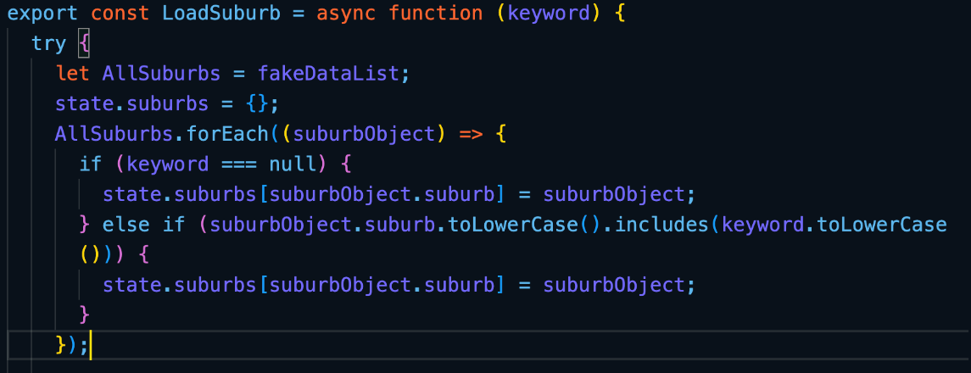

Figure 1 Part of Code Screenshot in Model Part to Grab Matching Data

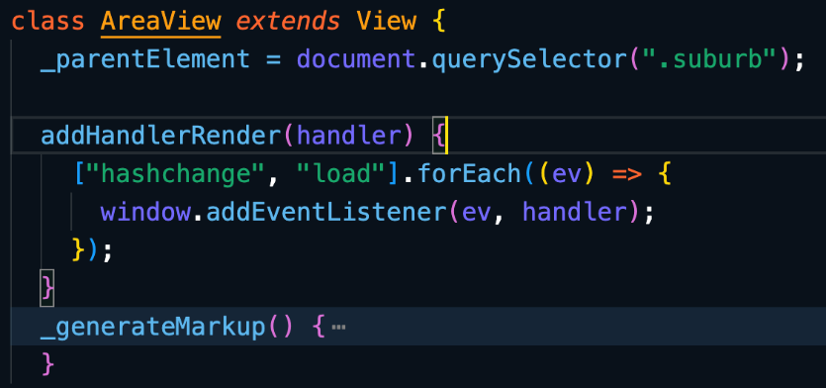

Figure 2 Part of Code Screenshot in View Part to Render Suburb Information

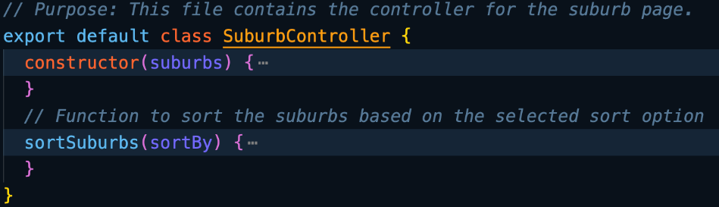

Figure 3 Part of Code Screenshot in Controller Part to Handle the Sort Status

This workflow ensured that our users could receive real-time feedback when interacting with various areas of our web page. It allowed us to manage multiple functionality states with 'addEventListener', such as sorting and searching, enhancing the maintainability and scalability of our site.

**Client-side Data Storage**

During interactions on our *Properties* and *Profile* pages, users can save specific properties for easy retrieval in their profiles. This feature was implemented using HTML's Local Storage functionality. We stored the selected properties' IDs on the client side, using them as primary keys.

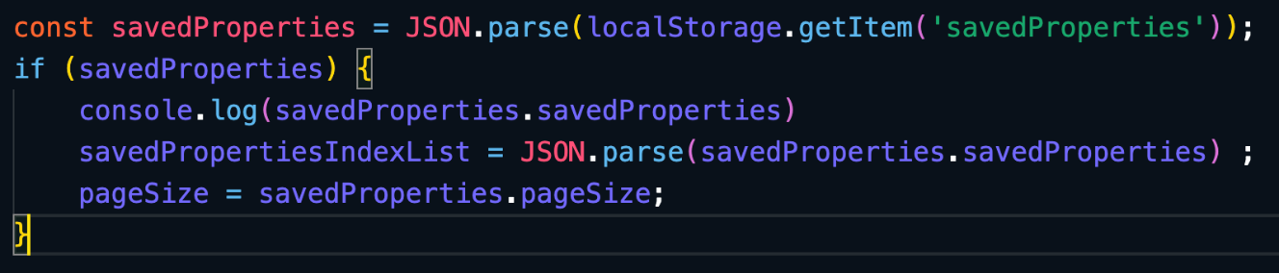

Figure 4 Part of Code Screenshot in Profile Page to Get Data from Local Storage

When users navigate to their profiles, we store the property IDs from Local Storage and then use these IDs to fetch the corresponding properties, which we display using a carousel-style layout as the following picture

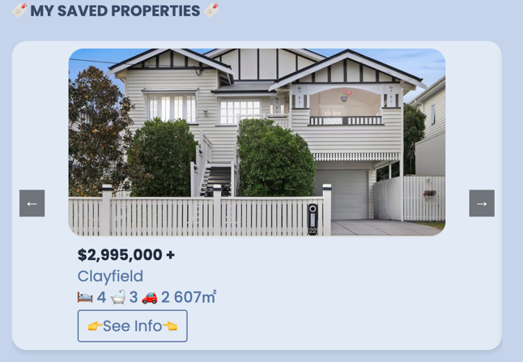

Figure 5 Carousel-style of Saved-Property Function

This functionality ensures even in the absence of a login/logout page, this approach allows users to save information of interest. This not only elevates the interactivity of our web page but also satisfies users' need to save property data, thus enhancing the overall user experience.

**Object-oriented Programming**

In our map page, despite processing backend data, the Leaflet library could not efficiently handle three different data types and render them separately on the map. To overcome this, we leveraged object-oriented programming (OOP) principles.

We transformed different types of disaster data into specific objects and passed these into the Leaflet rendering methods. This approach not only assures the maintainability of our website but also supports the integration of more diverse disaster data in the future. This capability satisfies our target users' specific requirements of filtering different types of disasters, thus enhancing the adaptability and usefulness of our site.

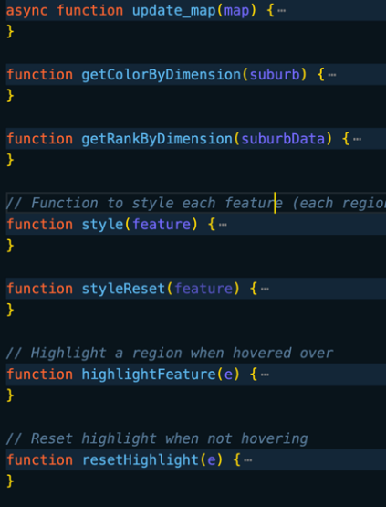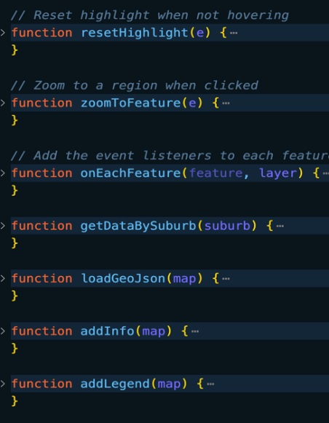

Figure 6 Object-oriented Programming Style for Handling Different Types of Data

1. **API Integration**

Our website mainly leverages the Leaflet and Google Charts APIs to boost interactivity.

* **Leaflet Library**

Initially, we utilized the Leaflet library as it can allow our users to better specify different suburbs' locations in Brisbane. However, as we progressed with user testing after prototype development, we discovered that the suburb markers provided by Leaflet were not distinctive enough for users to specify. As a solution, we retrieved geographical boundary data (longitude and latitude) for each suburb from the crime cases dataset. These data points were used to draw polygon boundaries as a separate layer on the Leaflet map, thus enhancing the distinctness of different suburbs. This use of the Leaflet library helped users interact more accurately with specific areas and familiarize themselves with Brisbane's regions.

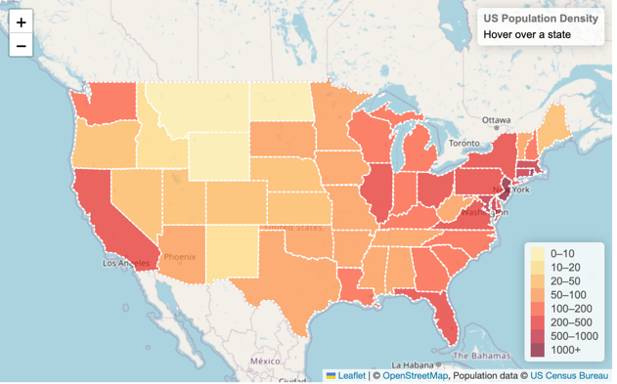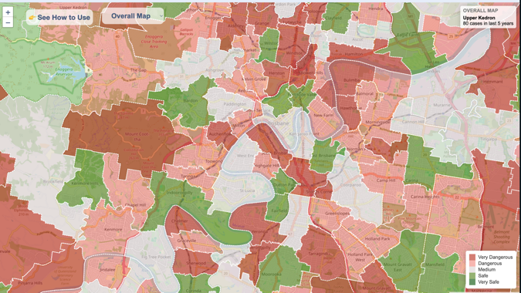

Figure 7 Map Sample of Leaflet Website (Left) & Our Use of Leaflet Library (Right)

* **Google Charts**

We integrated the Google Charts API to present bushfire, flood, and crime case data interactively across different areas. Google Charts not only ensures users can click on each icon for data interaction but also offers a variety of presentation styles like donut charts, line charts, and bar charts. These visualizations help users compare different areas and the average values for all areas in Brisbane from multiple perspectives. Consequently, users gain more comprehensive insights, enabling them to make more informed decisions when deciding suburbs they wish to move to.

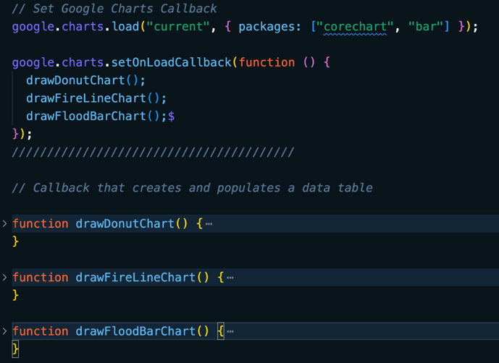

Figure 8 Part of Code Screenshot of Using Google Chart API

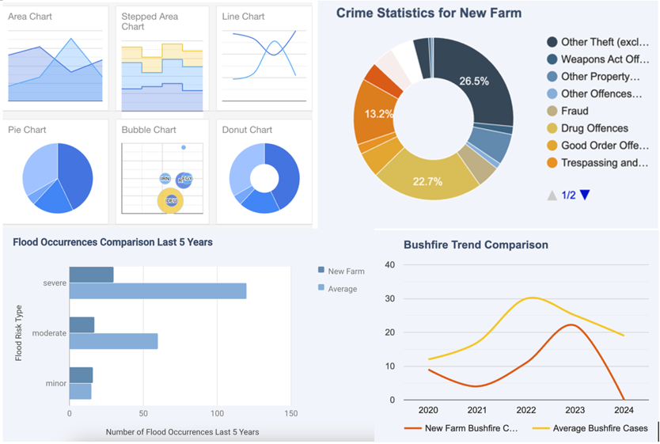

Figure 8 Sample of Google Chart API (Top-left) & Our Use of Different Chart (the Rest)

In conclusion, our choice to integrate those technologies into BriSentinel have proven to be crucial to allow us to create a more interactive, and robust website. The emphasis we placed on above technologies demonstrates our group's approach to adjust and enhance our technological utilization based on the evolving needs of our users. This shows our belief in user-focused programming, where the user experience and needs are the driving force behind our development decisions.

## Utilized Datasets and Its Interactivity

### SLQ Datasets

We have chosen three datasets from the SLQ database. They are **Crime Map**, **Flood Awareness Creek** and **Wild Fire History** respectively. To better utilize these data and correctly display information from these data, we have used *Postman* as our dev tool to figure out the the request and response format while calling the provided APIs.

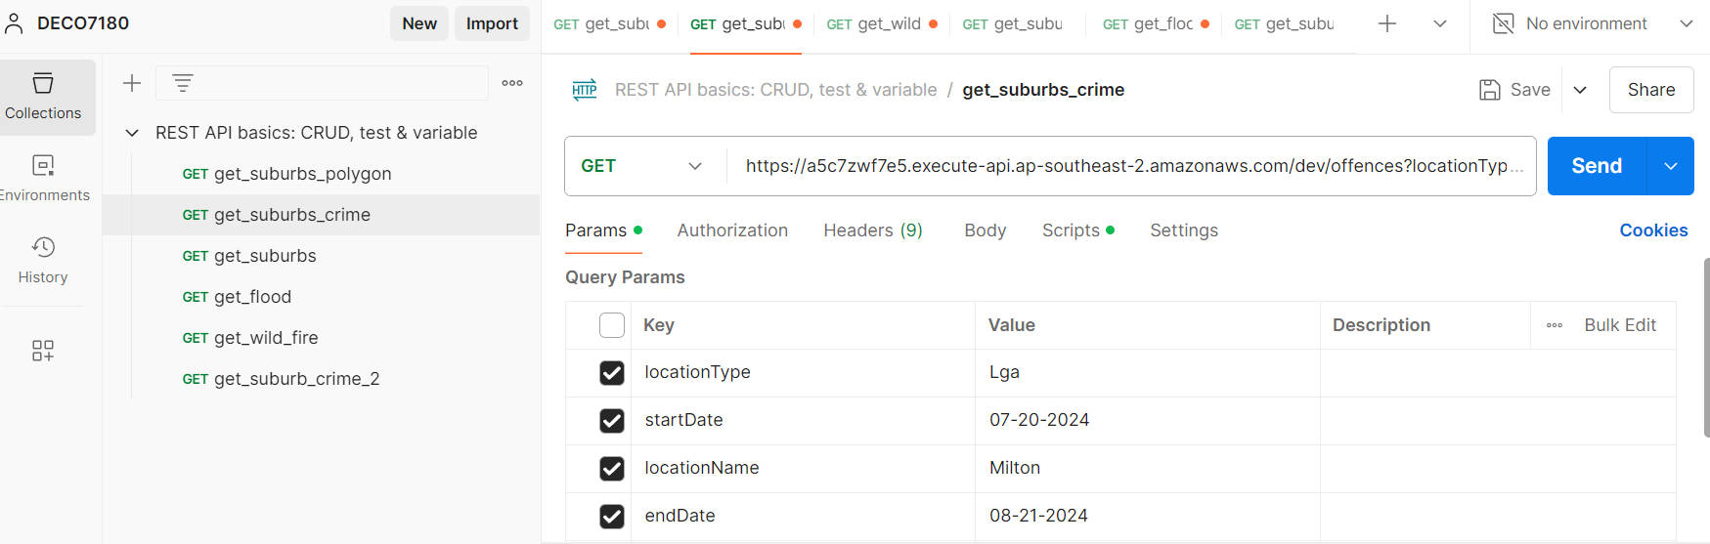

Figure 1Postman Interface Including all APIs used

#### Crime Map

Crime Map is the most complicated dataset among the three.

##### Purpose

We have used it for two main purposes.

1. Crime case retrieval of each suburb as its name suggests.
2. Geographical information retrieval on each suburb mainly for polygon boundaries data, which is essential for the drawing of Leaflet on our *Risk Map* page later.

Below are the two examples on how we have used Crime Map. The first one is to get crime cases of St Lucia and the second one is to get the geodata of St Lucia.

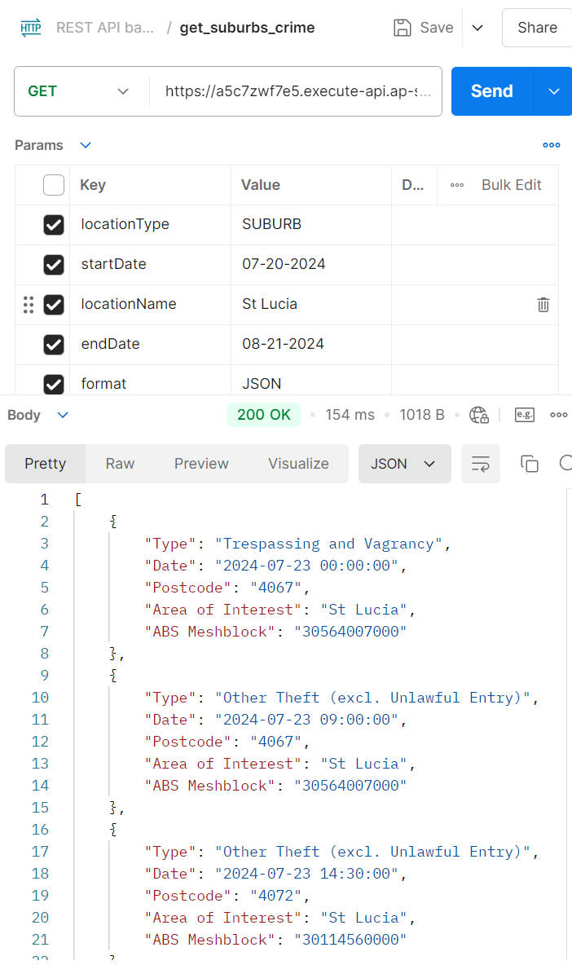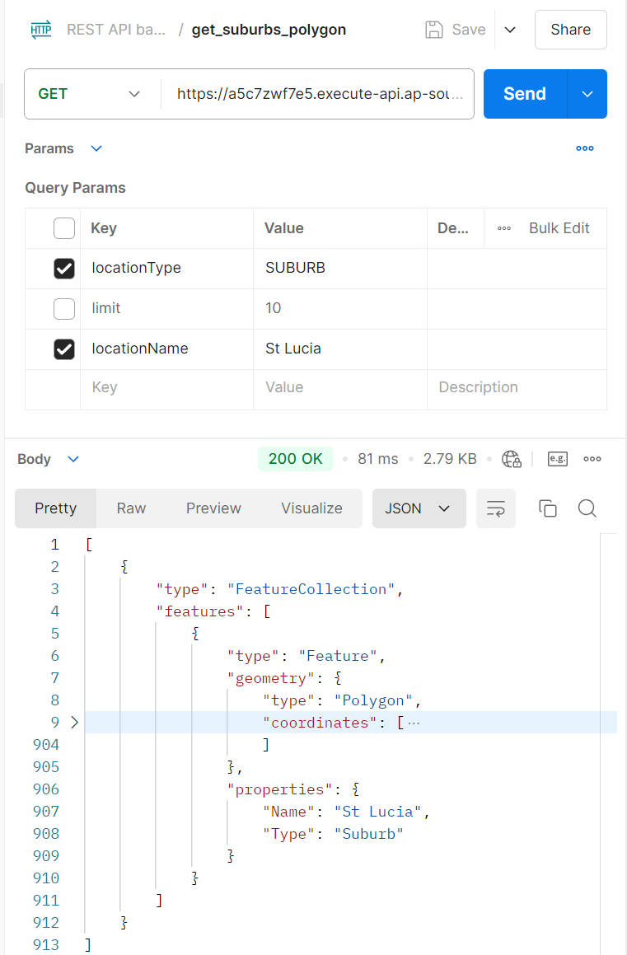

Figure 2&3 Crime Map to Get Crime Cases & Geographical Data of St Lucia

##### Data Process

We have to further process data from Crime Map.

1. **Geographical Data**: It has two features.
   1. It is static data and is unlikely to change in the foreseeable future.
   2. It is heavily loaded if all suburb information is integrated together due to the complicated boundary data.

* Considering these features, we have saved all geographical data into a JSON file, which we will not modify again once we finish the process. By doing so, we can guarantee the *Risk Map* can get the needed data quickly.

1. **Crime Data**: It works for one purpose.

* We will first call API to fetch all crime data in the last five years of each suburb. Next, we will group the retrieved data by the crime type and get the total count of each crime. Then we will store it into a JSON file so that later *Chart* page will utilize it to display detailed data on each crime of one suburb in a doughnut chart.

#### Flood Awareness Creek

Flood Awareness Creek offers data on the flood information of Brisbane.

##### Purpose

We have used it for getting information on how a suburb has been affected by flood in the last five years. Such data will be displayed on both *Risk Map* and *Chart* pages. Below is how the data looks for one call.

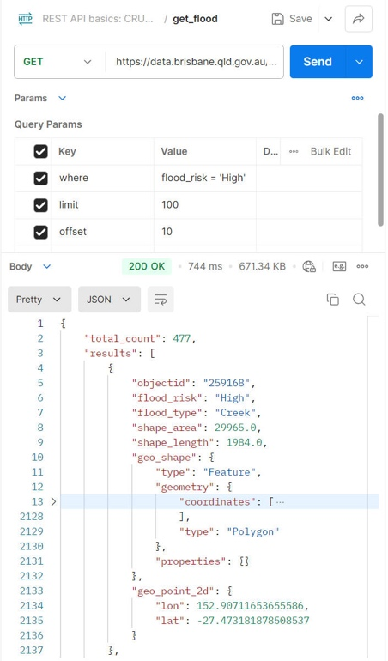

Figure 4 Flood Awareness Creek to Get Data of High Flood Risk

The data has categorized flood threat level into four levels, which are 'High', 'Medium', 'Low' and 'Very Low'. The order of magnitude for 'Low' data amount is much higher than the one for 'High' level, which imposed some challenges for data processing to be explained in the next part.

##### Data Process

We have faced two big challenges while processing the data returned.

1. **Limit of 100**: For each call only a maximum of 100 rows can be fetched. So to get all the needed data, we have to do repetitive calling around 1000 times. This would be a big performance issue if data were retrieved on the fly, hence we decided to store data into a JSON file as a cache for more quicker response.
2. **Determine Flood Threat on Each Suburb**: The data retrieved does not provide direct information related to each suburb. So we need to implement a function to determine whether a suburb was affected by the flood. Fortunately, *Leaflet* provided an API to calculate the distance and we are able to compare the distance between flood centre and the suburb centre with the flood range to check if the suburb is affected.

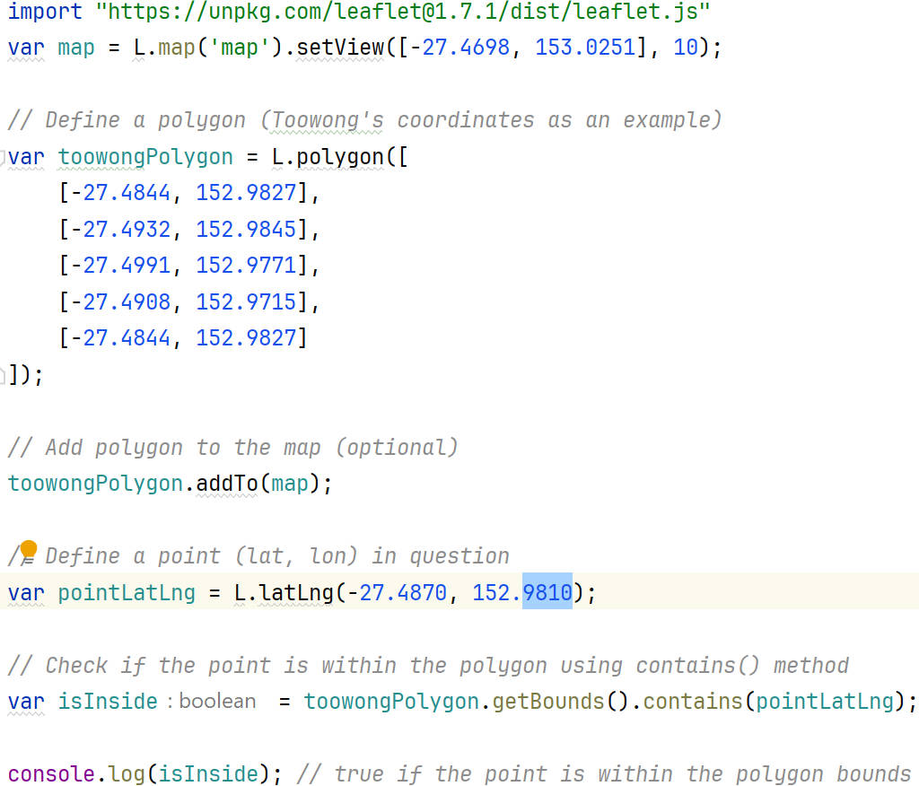

Figure 5 The Example API from Leaflet to Calculate Distance

#### Wild Fire History

Wild Fire History offers data on the wild fire history in Brisbane.

##### Purpose

We have used it to retrieve information on how a suburb has been affected by wild fire. It is quite similar to Flood Awareness Creek on the format of data. But it has a much smaller amount of data and is much easier to process with the experience of Flood Awareness Creek. Below is how the data looks in one call.

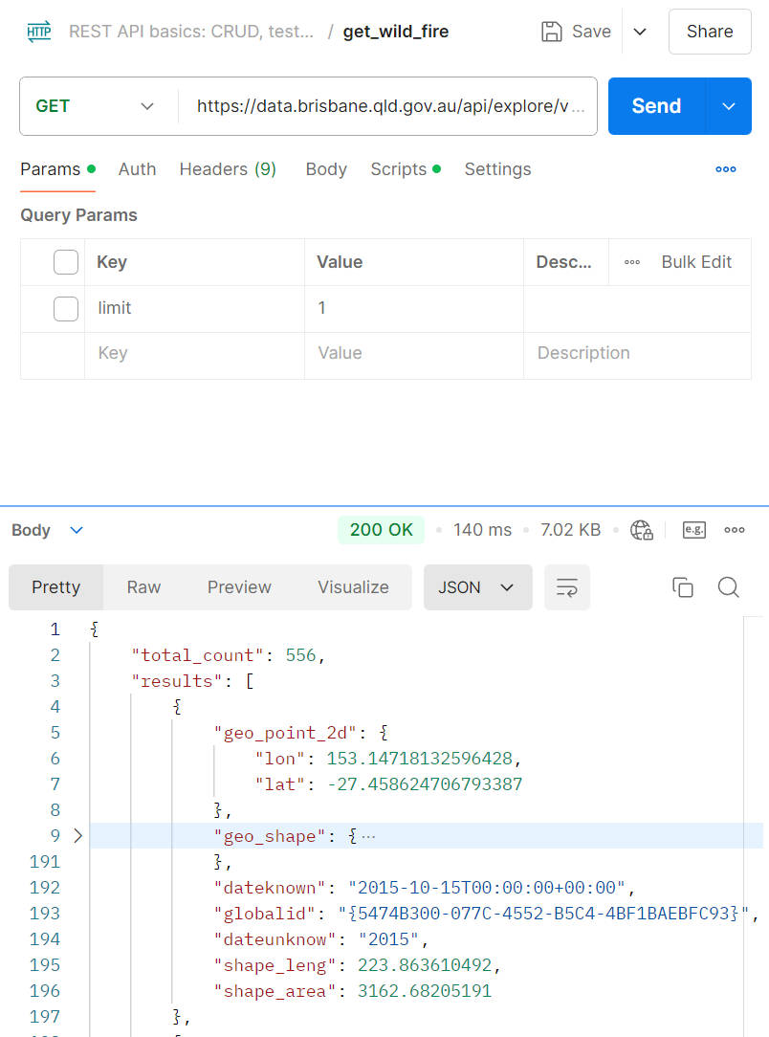

Figure 6 Wild Fire History to Get All Data in Brisbane

##### Data Process

Like Flood Awareness Creek, we have to use *Leaflet* API to check if a suburb was affected by wildfire. It had the same process as explained in the previous part.

### Other Datasets

Except for the required datasets from SLQ, we have also used other datasets for simulation purpose.

#### [RealEstate](https://www.realestate.com.au/)

RealEstate is the website we have referred to for two purposes.

1. Retrieve data for average housing and rental price of each suburb for the *Rank* page.
2. List simulated properties for the *properties* page.

#### [Wikipedia](https://www.wikipedia.org/)

Wikipedia is the website we have used to get necessary information like suburb images and description for the *Rank* page.

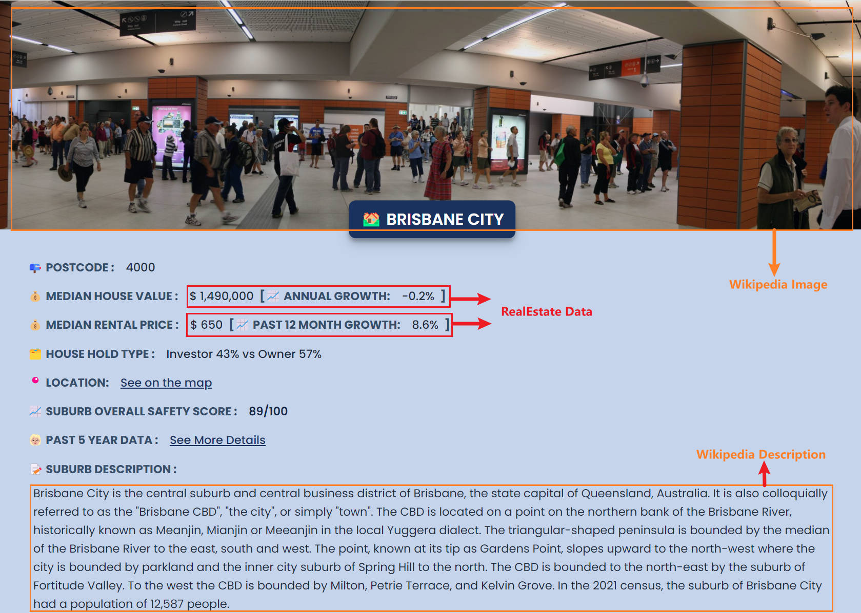

Figure 7 Usage Example of Other Datasets on Brisbane Court